UI Customizing created:
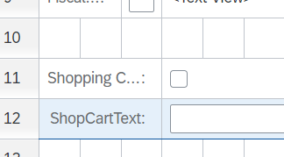

Gov scope:

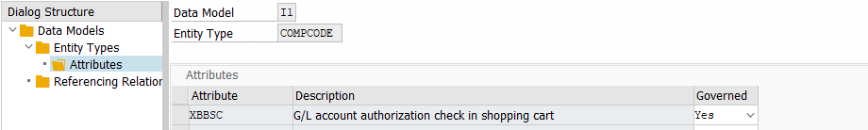

No Update in T001:

Local Scope changed:



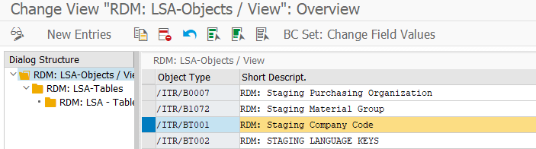
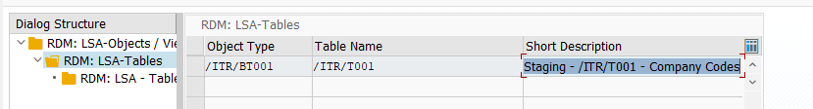

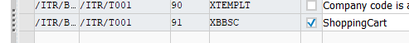

Now it works:

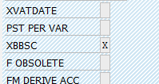

The entry is not only missing in IH1400 but also in IR1 and IR2.

This entry should be added (in non active mode) … Customer than needs to “activate this
